**Lab 4**

**Scenario**

**Lemon Soda Service**

“Thela”, lemon soda offering company has decided to take orders online. Customer places the order online and at the time of delivery pays the bill. Order is prepared and delivered by the delivery man to the customer. Customer pays the bill to the delivery man.

Customer and Delivery man both are the person. Introduce the concept of super type and subtype in the ERD drawn in Lab 3.

**Solution**

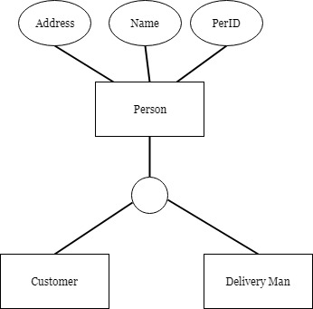

**Mechanism to Conduct Lab:**

Lab will be conducted via Adobe Connect.